**Assembly Homework Ch 3**

**Your Name: 謝豐安 Student ID (學號):A1055548**

**Problem1**

1. Print your executing results 20% (貼上執行結果20%)

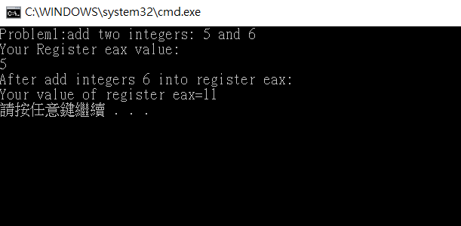

2. Source Code 20% and Comments 60% (程式原始碼20%與程式註解說明50%)

INCLUDE Irvine32.inc

.386

.model flat,stdcall

.stack 4096

ExitProcess PROTO, dwExitCode:DWORD

.data

stradd BYTE "Problem1:add two integers: 5 and 6",0dh,0ah,0

str1 BYTE "Your Register eax value:",0dh, 0ah, 0

straf BYTE "After add integers 6 into register eax:",0dh,0ah,0

strsum BYTE"Your value of register eax="

sum DWORD 0 ; store the sum of 5+6

.code

main PROC

mov edx, OFFSET stradd ;move the address of stradd to edx

call WriteString ;print stradd

mov edx,OFFSET str1 ;move the address of str1 to edx

call WriteString ;print str1

mov eax ,5 ;move 5 to register eax

call WriteDec ;print eax in decimal

call Crlf ;print a space line

mov edx,OFFSET straf ;move the address of straf to edx

call WriteString ;print straf

mov edx,OFFSET strsum ;move the address of strsum to edx

call WriteString ;print strsum

add eax,6 ;add 6 to register eax

call WriteDec ;print eax in decimal

call Crlf ;print a space line

exit ;end program

main ENDP

END main

**Problem2**

1. Print your executing results 20% (貼上執行結果20%)

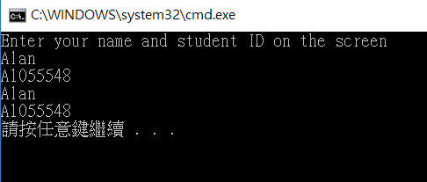

2. Source Code 20% and Comments 60% (程式原始碼20%與程式註解說明50%)

INCLUDE Irvine32.inc

.386

.model flat,stdcall

.stack 4096

ExitProcess PROTO, dwExitCode:DWORD

.data

str1 BYTE "Enter your name and student ID on the screen",0dh,0ah,0

keyName BYTE 21 DUP(0)

keyID BYTE 21 DUP(0)

.code

main PROC

mov edx,OFFSET str1 ;move the address of str1 to edx

call WriteString ;print str1

mov edx,OFFSET keyName ;move the address of keyName to edx

mov ecx,SIZEOF keyName ;move the size of keyName to ecx

call ReadString ;read string to keyName

mov edx,OFFSET keyID ;move the address of keyID to edx

mov ecx,SIZEOF keyID ;move the size of keyName to ecx

call ReadString ;read string to keyID

mov edx,OFFSET keyName ;move the address of keyName to edx

call WriteString ;print keyName

call Crlf ;print a new line

mov edx,OFFSET keyID ;move the address of keyID to edx

call WriteString ;print keyID

call Crlf ;print a new line

exit ;end program

main ENDP

END main